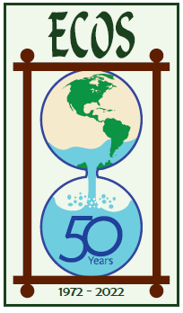
ECOS: The Environmental Clearinghouse
Environmental experiences, education, preservation

Membership Application

____ $40 Individual _____$50 Family _____$20 Student ____$75 Donor/Organization
____$100 Supporter _____$150 Sustainer _____$250 Benefactor _____$500 Patron
Name_______________________________________________________________________
Address_____________________________________________________________________
Email______________________________ Phone____________________________________

ECOS is a 501(c)3 organization.
____As a GE employee (or retiree), my contribution is eligible for GE Foundation Matching Funds. I have registered with GE for the matching gift by computer at www.gefoundation.com. Or call 1-800-305-0669.
____My employer will match my contribution. I’ve enclosed my matching gift form.
________
- ECOS’ strength is its members -
How can you help our quest for a healthy environment?
___ Give / attend talks or classes for adults ___ Guide / take walks, Spring / Fall
___ Lead / help with activities for children ___Organize / assist with events
___ Fundraising / grant writing ___ Computer skills / website
___ Design / art skills ___ Lead /assist Winter activities
___ Write/research articles ___Assist with publications
___ Other _________________________________________________________________

MAIL TO: ECOS, P.O. Box 9118, Niskayuna, NY 12309

For more information: 518-370-4125 info@ecosny.org | www.ecosny.org

