Rachel Carson Celebration
A virtual celebration
Tuesday, October 27, 2020
ECOS: The Environmental Clearinghouse will hold its annual Rachel Carson Celebration using Zoom. The evening will include dinner provided by SUNY Schenectady, the Rachel Carson Award and speaker Mark Lowery, NYS Department of Environmental Conservation.

New York’s Response to the Challenge of Climate Change
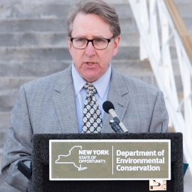
New York State is responding to the challenges posed by climate change through programs to reduce the state’s contribution to global greenhouse gas emissions and to adapt to the inevitable consequences of climate change. In particular, the Climate Leadership and Community Protection Act of 2019 puts the state on a nation-leading path to reduce greenhouse gas emissions while ensuring a just transition to a clean-energy economy.

Mark Lowery will describe anticipated effects of climate change on New York’s communities, residents, businesses and natural resources, and necessary solutions. His presentation will include a summary of the CLCPA’s requirements and an update on implementation of this law. He will describe New York’s continuing work to reduce its greenhouse gas emissions, despite the current lack of federal leadership, and programs to identify and mitigate climatic hazards. Finally, he will describe the critical role local governments must play in meeting the state’s emission reduction requirements and state support for local action through the Climate Smart Communities program.

